Bee Thinking cedar top bar hives

ABOUT TOP BAR HIVES
Top bar hives and top bar hive kits for sale made from Western Red Cedar. Resources, including the history, advantages and ideal placement of this simple to manage beehive.

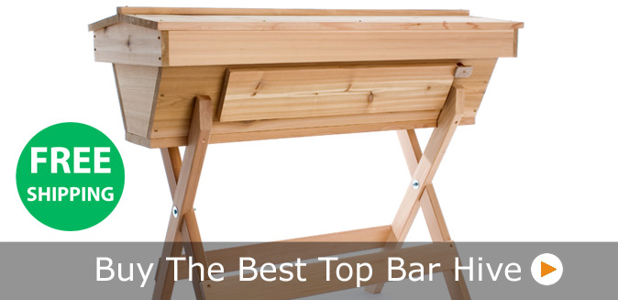
What is a top bar hive?
A top bar hive is any hive that uses only bars of some sort, usually with a starter strip of foundation, popsicle stick or wedge from which the bees build their own comb. Top bar hives do not use foundation or frames like traditional Langstroth, WBC or other more commercial hives.
Most top bar hives are long, and are often called horizontal top bar hives, as the bees build their comb horizontally rather than vertically. Most horizontal top bar hives are 3 to 4 feet in length, 15 to 20 inches in width and 12 to 16 inches in depth. Bars are usually 1 3/8” to 1 ½” wide to accommodate bee space between the combs. Depending on the width of the bars and length of the hive, the number of bars range from 20-40 in each top bar hive.
Entrances vary dramatically depending on personal preference. Some beekeepers use entrances in one end of the hive, others one or multiple entrances along the side, and some simply leave a gap between the bars and the end of the hive through which the bees come and go.

Our top bar hives

Click here to buy a top bar hive
Our top bar hives are constructed from sustainably harvested Western Red Cedar in Portland, Oregon. They are 42 inches long, 18 inches wide and about 13 inches deep, making them the largest readily available top bar hive. They feature 3 side entrances that can be reduced with bungs (included). 2 follower boards (dividers) are included for easy management of the colony or colonies within the hive.
Learn About What Makes Our Hives Better Than the Competition
A 29"x5” viewing window is included with all of our top bar hives, useful both for management purposes as well as enjoyment when visitors stop by to ogle your bees.
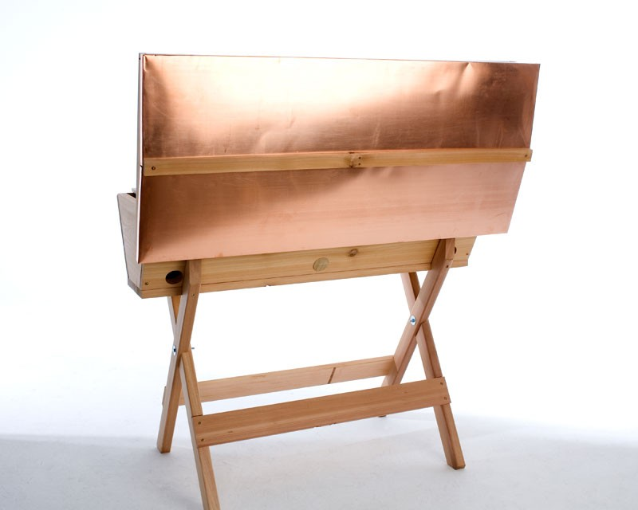Unlike most of our competitors, our hives come with both a roof and a stand (optional) – meaning that all you will need to provide is a space and bees! With the hive on the stand, the top of the hive is approximately 36” high, making the hive easy to work for those of average height .
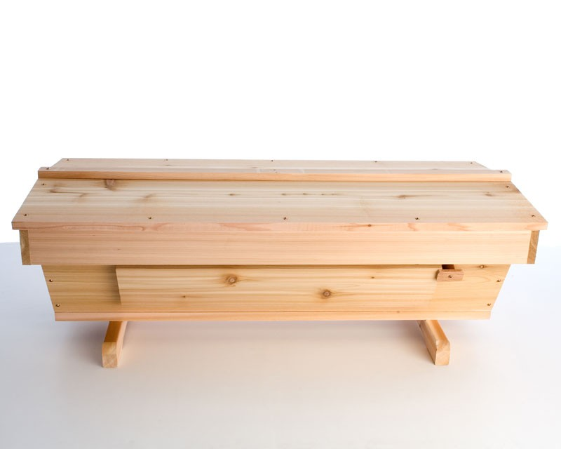
End entrances vs. Side Entrances
There is much debate as to whether end entrances or side entrances are superior. Our opinion is that side entrances are more versatile, as with the use of follower boards, side entrances make access to the brood and honey chambers much easier. With an end entrance it can be quite difficult to move enough bars of comb out of the way to reach the combs nearest the entrance. With side entrances there is empty space on each side of the colony, meaning that the beekeeper can go into the hive starting on either side with little disturbance to the bees.

HISTORY OF TOP BAR HIVES
History of top bar beehives and top bar hive beekeeping.

How did they start?
Top bar hives in one form or another have likely been used for thousands of years. There is evidence that were once used in Greece in the form of a pot or basket with sticks laid across the top. They are one of the most basic methods of managing bees, as they are simple to build, simple to manage and are more advanced than a skep or cavity from which the comb cannot be easily removed.

ADVANTAGES OF TOP BAR HIVES
Advantages of top bar beehives.

Why top bar hives?
Top bar hives are less expensive to build or purchase than Langstroth or other foundation/frame-dependant beekeeping equipment. They do not require honey supers, extra frames, foundation, queen excluders, uncapping knifes, extractors or other expensive tools; they almost fully self-contained beehives.
In addition to being a low-cost alternative to traditional equipment, they are significantly easier to work in than a Langstroth hive. When one inspects comb in a horizontal top bar hive, only 1 comb at a time is exposed, thus leaving the rest of the colony undisturbed. This makes for less agitated bees, and a more enjoyable experience for the beekeeper.
There are no boxes to lift. This alone has led many a beekeeper with an aching back down the path of top bar beekeeping. Traditional honey supers and deeps can weigh upwards of 50 pounds each, which takes its toll on the body of the beekeeper. The heaviest comb you’ll need to lift with a horizontal top bar hive is a single 3-7 pound, honey-laden top bar!
In recent years there has been a resurgence in foundationless, top bar beekeeping throughout the world as beekeepers look for low-cost, low-impact alternatives to traditional Langstroth, frame beehives. They are especially effective in parts of Africa and other impoverished areas of the world that cannot manufacture or purchase the precision milled equipment required to use traditional hives. In many areas of Africa the top bar hive has been critical in turning low-profit honey hunting and log hive beekeeping operations into profitable endeavors. This has significantly improved the quality of life for the inhabitants of numerous villages.

TOP BAR HIVE PLACEMENT
Top bar hive placement consists in setting up the hive in a location that is ideal for both the bees and the beekeeper. Here we'll discuss the determining factors when placing your first top bar hive.
Top Bar Hive Placement: There are many factors to consider when placing any bee hive, however, horizontal top bar hives have some unique needs that should be addressed when deciding upon the final location.
Easy Access: While there are many "requirements" on the traditional "hive placement checklist," I think one of the most important factors to consider is ease of access for you, the beekeeper. The bees are adaptable, and can overcome just about any inconvenience you throw their way. If the location makes it difficult for you to enjoy the hive, and especially if it makes it difficult for you to work in the hive, this is a major issue. You will want a location that is free of obstructions on the backside of the hive (the side with the window), with at least 2-3 feet of space so that you can stand and squat comfortably. I assure you that you will spend more time than you know knelt down with friends and family while eagerly looking through the window to see the progress your bees are making. Try and provide enough space for at least 2-3 people to fit comfortably while looking through the window.
Level Ground: Horizontal top bar hives are foundationless, and the bees build their comb perpendicular to the ground. If your hive is on a slope, the comb will be equally sloped. Make sure you either place the hive on level ground, or place garden tiles, rocks or scrap wood under the legs to make it as level as possible. This also makes it easier for you to access the hive without fumbling up and down a hill.
Early Morning Sun: While this doesn't apply to extremely hot areas, it is generally agreed upon that hives are more successful with more sun than less. If you have to choose between early morning sun and afternoon sun, go with early morning sun, as this will get the hive active earlier in the day, and provide them with more time to gather resources.
Safety: If you live in an urban or suburban area and you feel there is potential danger to either the bees or people, be sure to place the hive in a relatively concealed area -- preferably one that is fenced off. Many beekeepers who live in the city like to point the entrance of the hive toward a fence or a hedge
Wind: Ideally the hive will be placed in a location that is protected from harsh winds billowing into the hive entrances during the winter. Due to the leg configuration and weight, our hives are very sturdy and we've had no issues with hives being toppled by high winds.
Water: If you live in an arid region -- especially one where pools are prevalent -- this is consideration is more important. Bees need water to use within the hive, and they, being opportunists, will frequent the closest reliable water source, regardless of how inconvenient it is for you or your neighbors. If the closest water source is your neighbor's pool or bird bath, the bees will be more than willing to use them. If this matters to you, make sure you provide them with a shallow-sloped water source. Bird baths work very well!
Forage: Obviously if you plan to keep bees in your back yard you will have little control over the nectar and pollen sources available to your colony, but an important consideration nonetheless. We've had greater success with our colonies placed in urban and suburban areas, largely due to the abundance and variety of flower plants available in parks, gardens and yards. Rural areas, especially areas with heavy agriculture, generally have less forage available due to the use of mono crops, pesticides and fungicides.
Legality: The last, and maybe one of the most important factors, is whether it is legal to keep bees in your area. Many cities still outlaw beekeeping outright, or make the licensing process incredibly difficult for the beekeeper. Check your city, county and state laws prior to investing in a beehive and bees, and then make a decision accordingly. Keep in mind that a number of areas have antiquated laws explicitly banning the use of any hives but Langstroth or frame beehives. While I don't know of anyone being accosted over such silly regulations, it's still something to keep in mind.

TOP BAR HIVE MANAGEMENT
How to manage a top bar hive
After using Langstroth hives, Warre hives and horizontal top bar hives, we feel that horizontal top bar hives are the most enjoyable to manage -- especially for the new beekeeper. They do require more visits to ensure the colony always has ample space for honey storage, but with the use of the window and simple bar manipulation, the maintenance is quick and efficient.
When you get your bees you should install them at one end of the hive with the follower boards spaced in such a way that 8-12 bars are accessible to the colony. Open only 1 entrance (the one the colony has access to), leaving the rest closed up. Over the first few weeks the colony will rapidly build comb from the bars – it is at this time that you’ll need to play close attention to ensure that the comb is straight so you can easily manipulate it later on. If it is crooked or “cross-combed” you will need to gently push it back into place on the bar. If you fail to catch the cross-comb early on, the problem will be exacerbated and it will become almost impossible for you to remove single bars of comb.
As the colony grows you will want to move the center follower board toward the other end, providing them with more space to store honey and brood. Once there are only a few empty bars left in the hive, you will want to begin harvesting honey or moving honey from the full hive to weaker hives.
As winter approaches you will want to check that the colony or colonies have sufficient stores – 30-50lbs here in Portland, Oregon. If you have multiple colonies you can spread the surplus around to ensure all colonies have enough. Otherwise, depending on your beekeeping philosophy you can feed 2-1 sugar syrup (We rarely feed in our own apiary, even if a colony is low on stores). Reduce the entrances available (if you have one of our top bar hives, use the entrance reducing bung).

